1. Process: Attendance Process
2. Purpose: Assign faculty, Maintain timetable and marks student’s attendance in college
3. Screens in this process

|  |  |  |
| --- | --- | --- |
| **Screen Name** | **Purpose** | **Access By User Role** |
| Allot Batches | To divide students in batches for practical sessions | Education in charge |
| Assign Faculty | Assign courses to teachers | Section head |
| Maintain Timetable | Maintain timetable | Section head |
| View My Courses (teacher) | View courses assigned to teacher | Course teacher |
| View My Timetable (teacher) | View timetable of the course teacher | Course teacher |
| Mark Student Attendance | Mark absent students for theory/practical | Course teacher |
| View My Courses (student) | View courses taken by student | Student |
| View My Timetable (student) | View student’s timetable | Student |
| Print Student Attendance Report | Print student attendance report | Course teacher |
| Mark Defaulter Students | Mark defaulter students whose attendance is < 80% | Section Head |
| Print Debar candidate List | Print debar candidates list | College Exam office |

**4.1 Login Screen**

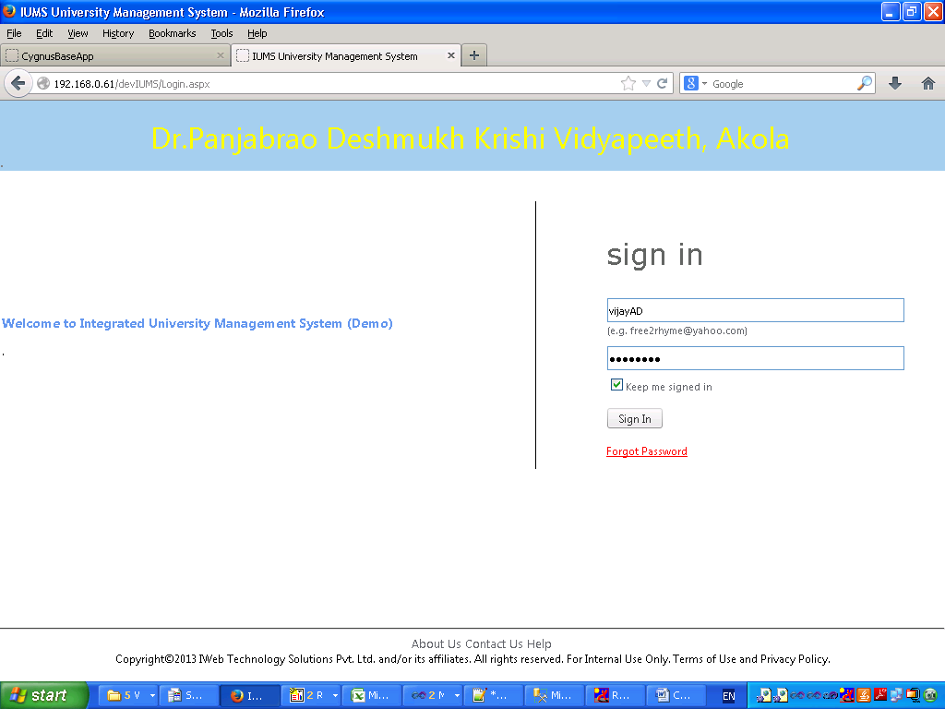

**4.2 Allot Batches**

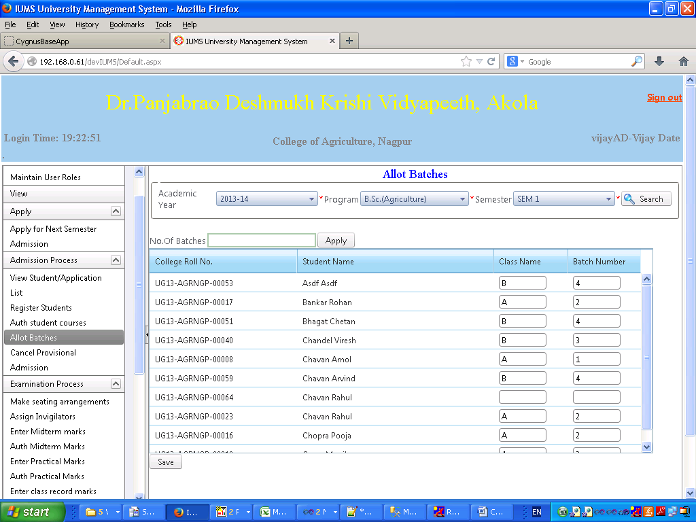

Screen Operation: Select academic year, program and semester. List of students in the selected criteria will be displayed. Enter number of batches in which to divide students. Click Apply button. The system will automatically assign a Class and a Batch number to the students depending on class capacity (defined at college level) and batch size (defined at system level). If you wish to change a student’s class or a batch, you can edit the same in the text box. Click Save button to save the data. A message “Data saved successfully” will be displayed.

**4.3 Assign Faculty**

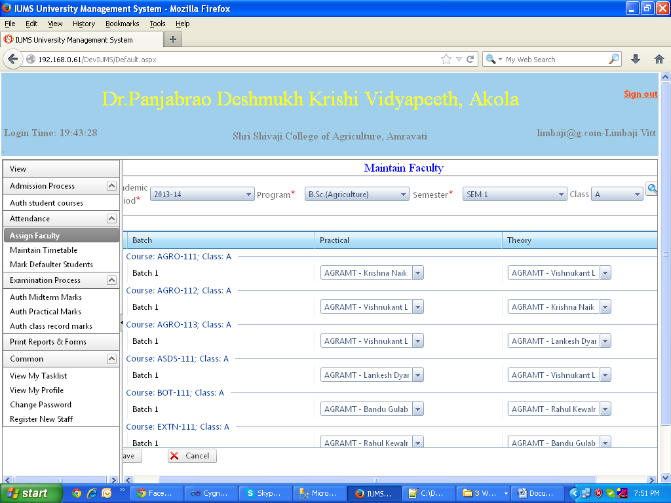

Screen Operation: Select academic year, program, semester and Class. Click Search button. List of Batches in the selected class will be displayed. Against each batch, 2 dropdowns will be displayed having list of course teachers in the college, one for theory and one for practical. In each dropdown, select one or more course teachers. Click Save button to save the data. A message “Data saved successfully” will be displayed.

4.4 Maintain Timetable

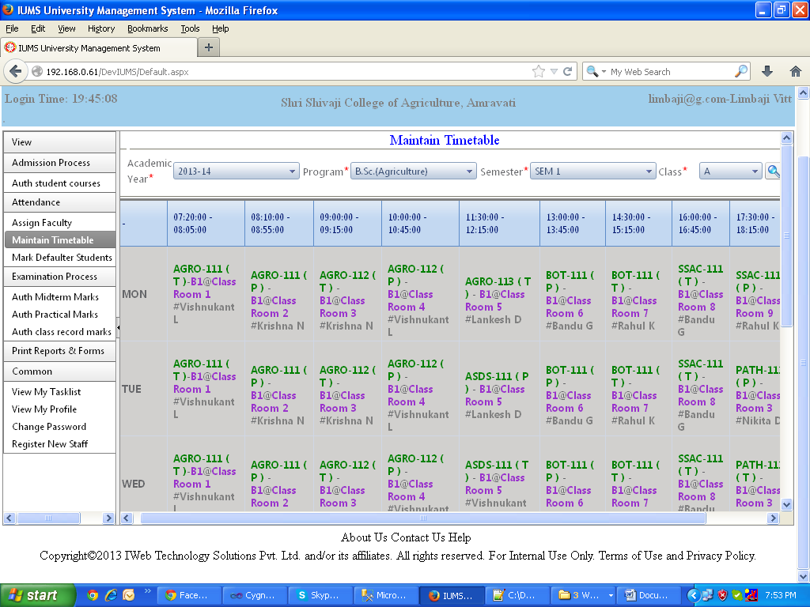

Screen Operation: Select academic year, program, semester and class. Click Search. The timetable of the selected class will be displayed with time slots on the horizontal scale and Weekdays on the vertical scale. Double click in a cell to assign the course, theory or practical, a course teacher and classroom for that day/time.

4.5 View My Courses

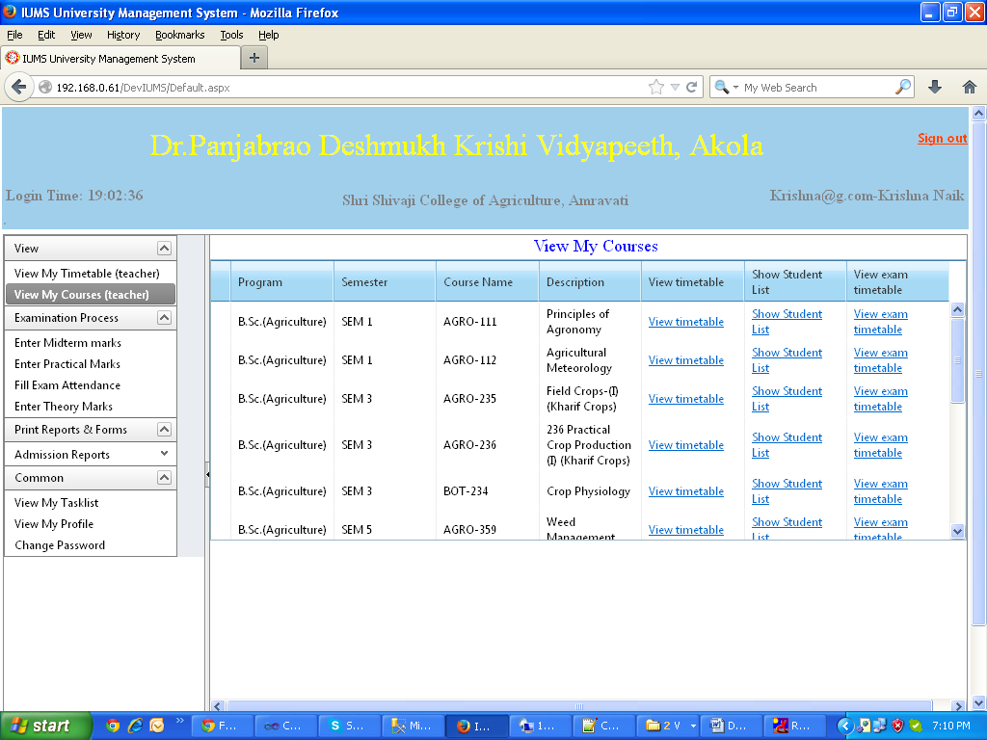

Screen Operation: When the course teacher user clicks on the menu for this screen, the screen will automatically display the courses which have been assigned to the user. Program, Semester, Course Name, Description will be displayed. Hyperlinks are provided to view the timetable of the course, view list of students who are registered for the course and view Exam timetable for that course. 4.6 View My Timetable (teacher)

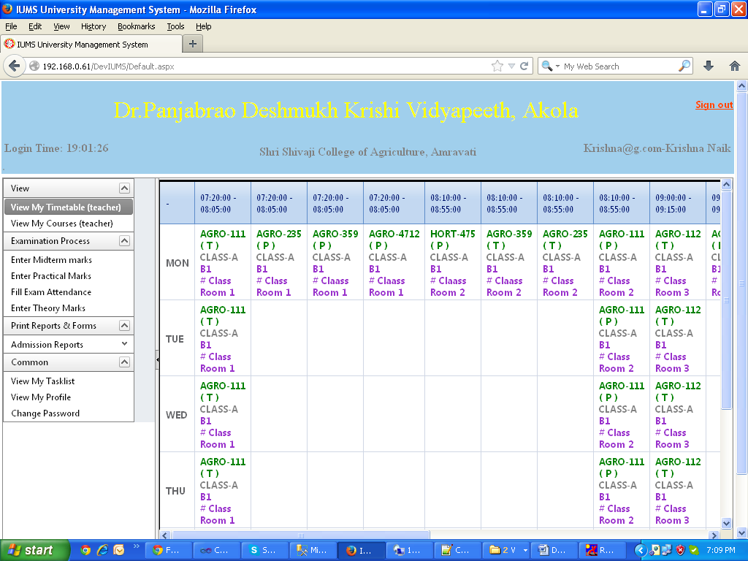

Screen Operation: When the course teacher user clicks on the menu for this screen, the screen will automatically display the timetable of All the courses which have been assigned to the user.

4.7 Mark Student Attendance

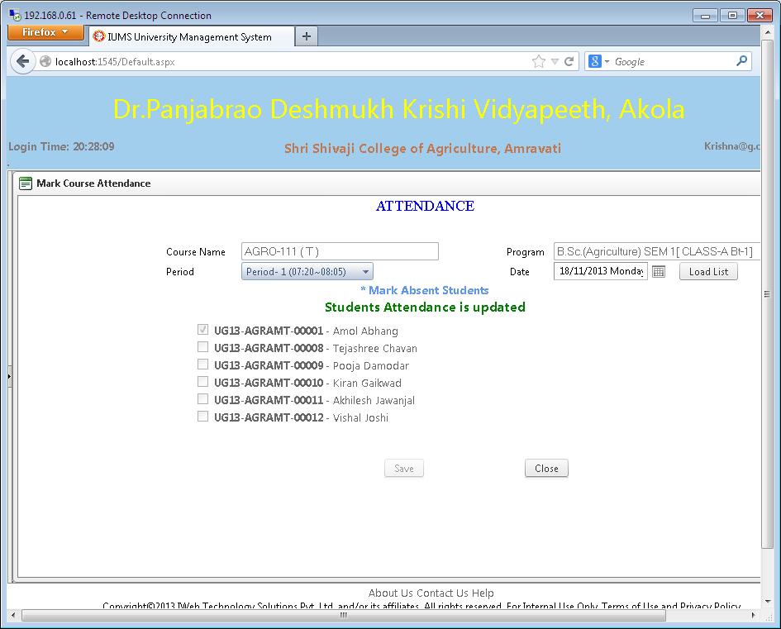

Screen Operation: Login as the course teacher user. View the timetable. Double click in the cell of the desired date/time cell of the timetable. The above screen will be displayed which has the list of students and roll numbers in the class/batch as per the timetable. The teacher has to mark only the absent students by clicking in the checkbox against the student. Click Save button to save the data. A message “Student Attendance is updated” is displayed.

**4.8 Print Student Attendance Report**

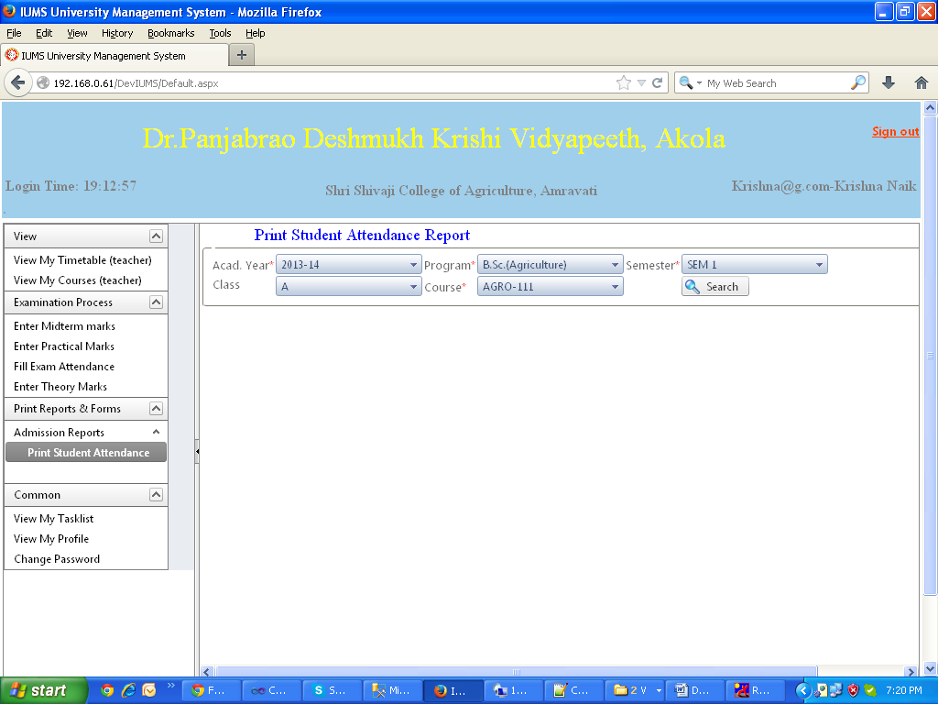

Screen Operation: Select academic year, program, semester, class and course. Click Search button.

The attendance report of the selected criteria will be displayed in a separate pop-up window.

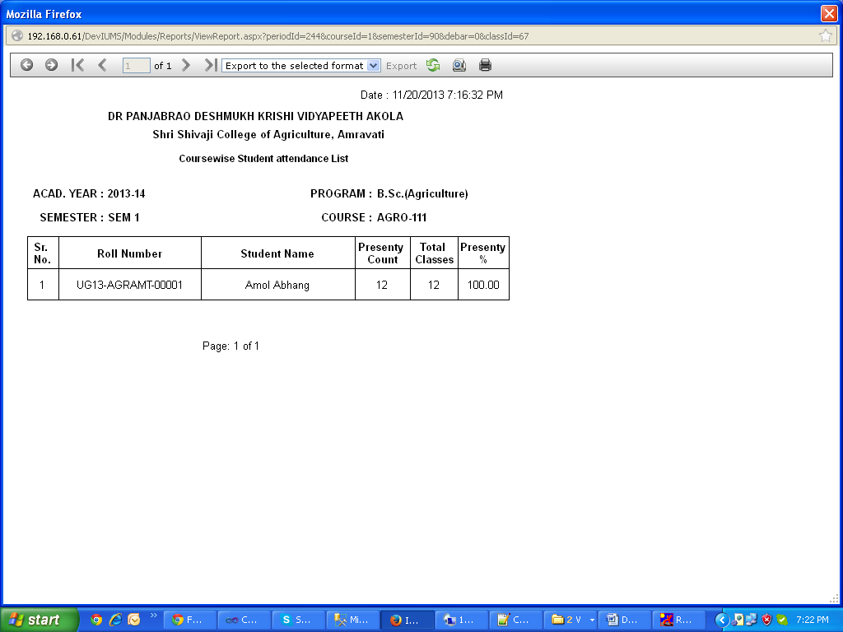

Click on the Print button to print the report.

4.9 View My Timetable (Student)

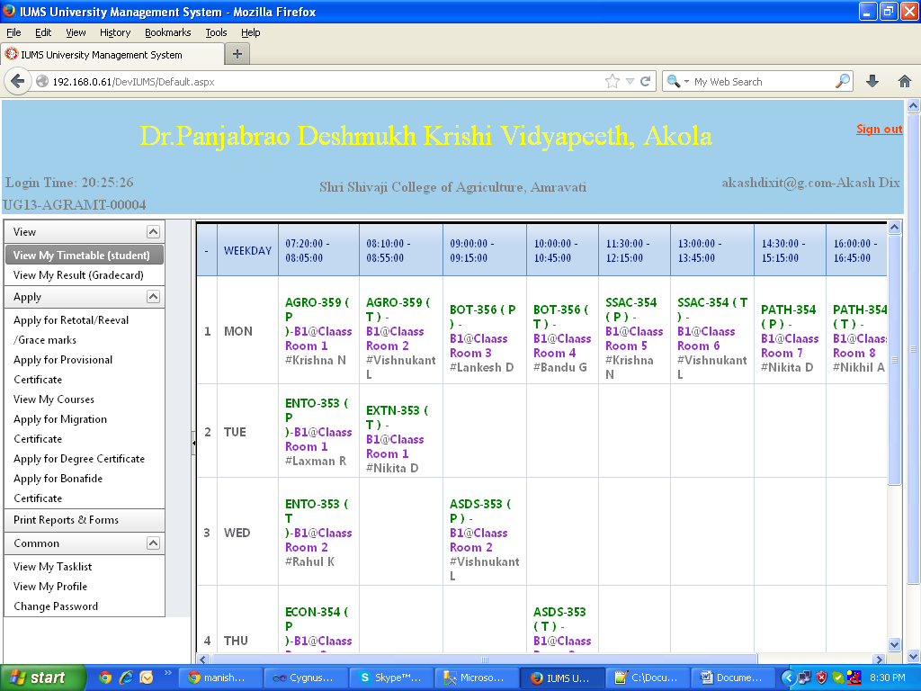

Screen Operation: Login as a student user and click the menu for this screen. The screen automatically displays the timetable of the class in which student is studying. The time slots are shown on the horizontal scale while days are shown on the vertical scale. Each cell shows the period , the course, Batch no., Theory or practical, Class room and teacher’s name for that period.

**4.10 Print Student Attendance Report**

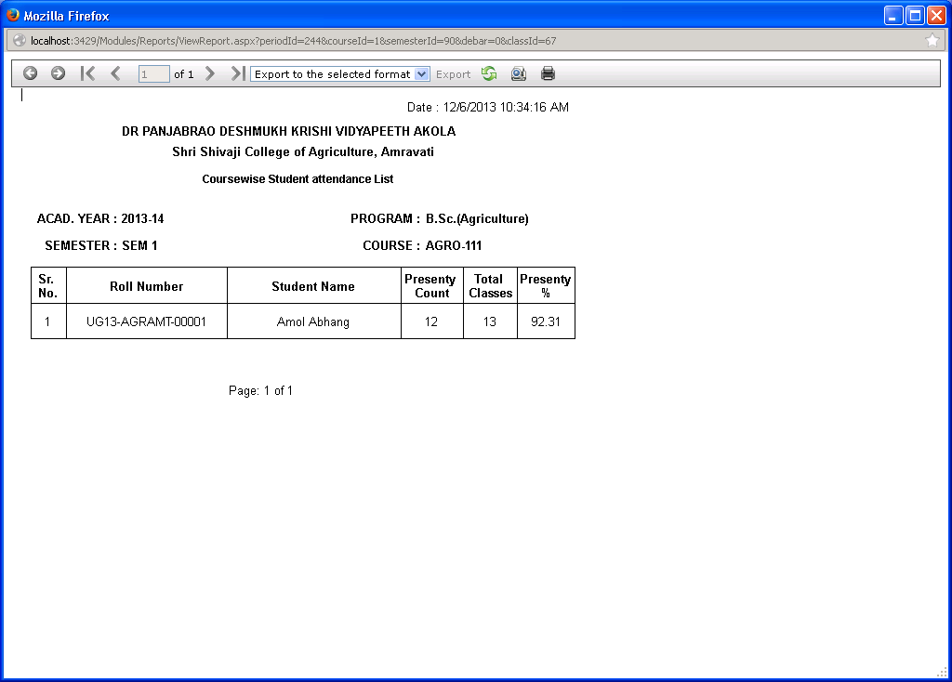

Screen Operation: Login as student and click on the menu for this report. The report shows the student how many classes were conducted, how many were attended and the percentage of attendance for the selected course.

4.11 Mark Defaulter Students

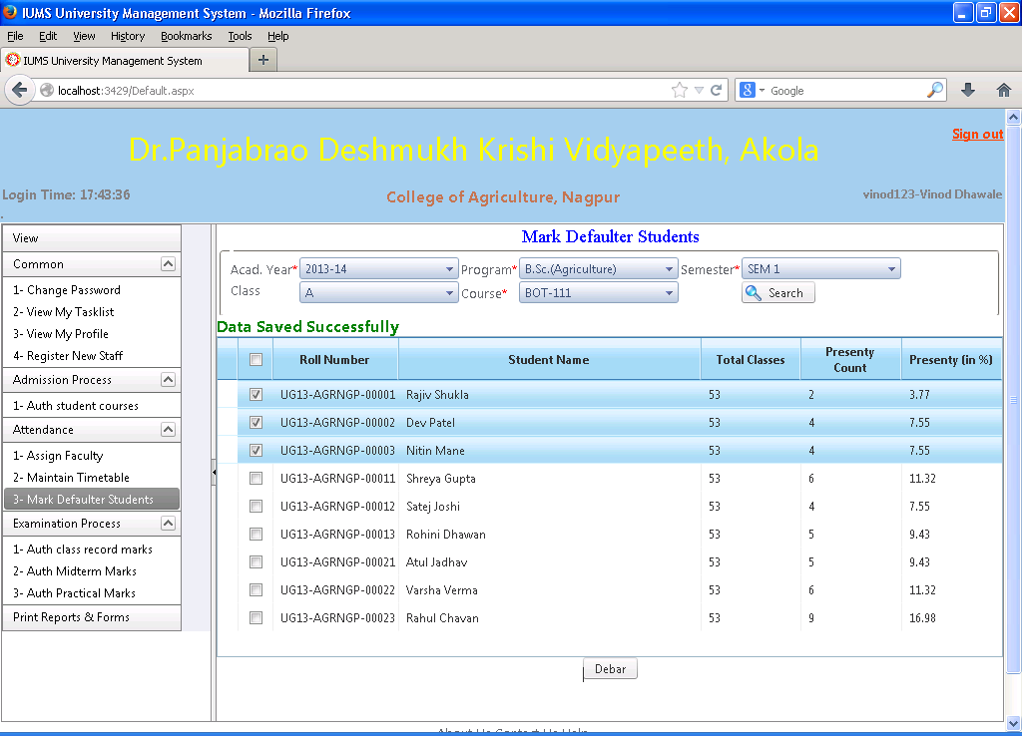

Screen Operation: Select academic year, program, semester, class and course. Click Search button.

The list of students whose attendance is less than specified percentage (80%) will be displayed in the result grid. Check the checkbox against the student whom you want to mark as Defaulter and he will be debarred from attending the examination of this course.

4.12 Print Debar candidate List

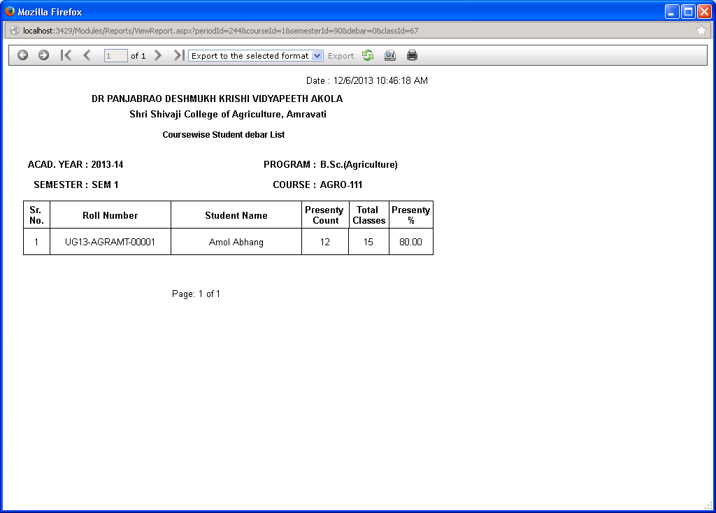

Screen Operation: This screen is used to print the report of students who have been debarred due to insufficient attendance as per the previous screen. The report shows student’s name, roll no., total classes held, present classes and percentage of attendance.

4.13 View Attendance (Student)

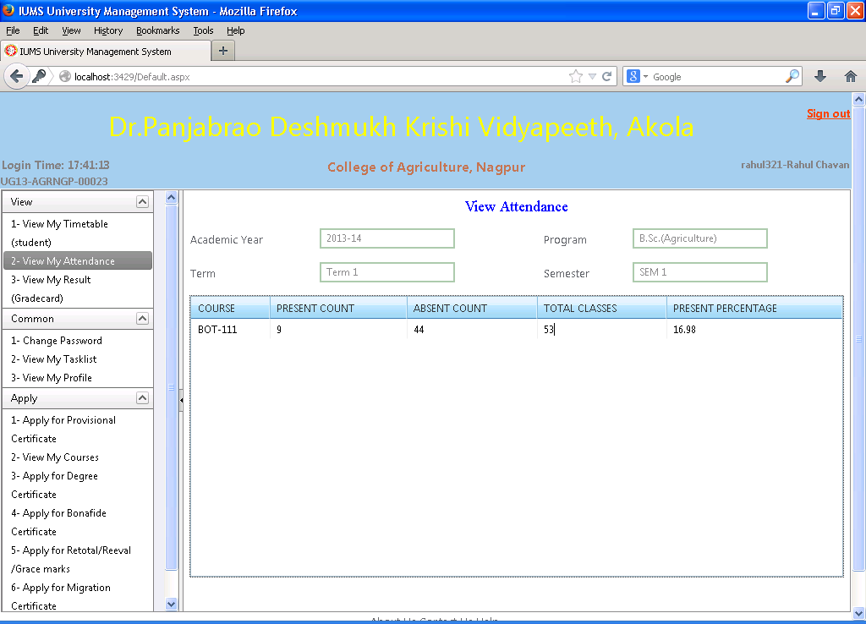

Screen Operation: Login as student and click the menu for this screen. The screen will automatically display the attendance report of the student. It will show for each course, present count, absent count, total classes and percentage of attendance. Using this screen, the student can know his attendance percentage in advance and make up for the absence so as to avoid getting debarred.